About this Lesson
Bring an Ancient Greek trading market to life in your classroom by allowing students to barter for items that would have been exchanged in this early civilization.

Grade Level | Course(s)/subject(s) | Learning Goal(s) | Suggested  Timing
4 | Social Studies | At the end of this lesson, students will:  - describe the uses of money (e.g., as exchange, trade, etc.)  - compare ways in which goods and services were traded in early civilizations to modern life | 40-50 minutes

Curriculum Links
Social Studies, grades 1-6 (2013)
Heritage and Identity: Early societies, 3000 BCE–1500 CE
A1. Application: Compare key aspects of life in a few early societies (3000 BCE–1500 CE), each from a different region and era and representing a different culture, and describe some key similarities and differences between these early societies and present-day Canadian society.

A2. Inquiry: Use the social studies inquiry process to investigate ways of life and relationships with the environment in two or more early societies (3000 BCE–1500 CE), with an emphasis on aspects of the interrelationship between the environment and life in those societies.

A3. Understanding Context: Demonstrate an understanding of key aspects of a few early societies (3000 BCE–1500 CE), each from a different region and era and representing a different culture, with reference to their political and social organization, daily life, and relationships with the environment and with each other.

Inquiry Question
How were goods bought and sold in an ancient market and how does this compare with modern-day markets?

Materials List
- Ancient Greece Trading Cards (Appendix A)
- Ancient Greece Trading Card Matching Words (Appendix B)
- Reflection on Trading Market Activity (Appendix C)
- Trading Market Reflection Rubric (Appendix D)

Timing  (Mins.) | Lesson Sequence | Assessment for and as Learning Opportunities (self/peer/teacher)
MINDS ON
5-10 minutes | WHOLE CLASS  Find your other half  Each student in one-half of the class receives a card showing an image of an item for trade in an Ancient Greek market. Each student in the other half of the class receives a card with a word that matches one of those images (Appendices A and B). If there are more than 24 students in the class, strategically place some students into groups of three by preparing extra image cards.  Provide time for students to find their match, but do not reveal the purpose of the items.  Have each partnership/trio share their item with the class. Ask students if they know what all of the shared items have in common. | Assessment FOR Learning (Teacher)
Context for Learning
- Students should be familiar with the concepts of buying and selling.

Timing  (Mins.) | Lesson Sequence | Assessment for and as Learning Opportunities (self/peer/teacher)
ACTION
20-30 minutes | WHOLE CLASS  Instruction  Explain to students that the products are items that would have been traded by people at markets in early Greek civilizations. Inform the class that the purpose of today’s lesson is to conduct a simulation in order to learn about Ancient Greek trading markets.
 | Using visuals (and video, if possible), instruct briefly on the following to set the historical context:  - General facts about Ancient Greek trading markets.  - The importance of trade in early civilizations.  - An overview of the geography of Ancient Greece.  - The significance of the sea in Ancient Greek trading.  - Environmental and geographic factors that affected the kinds of items that were brought to market and traded, with reference to the resources Ancient Greece lacked (consider hill and mountain terrain, proximity to the sea, etc.).  - Comparison of trade in ancient versus modern times. | Assessment FOR Learning (Teacher – anecdotal)
 | Have students take notes or use the template (Appendix E) where they can fill in key instructional points. You may also want to note that some of the products they will be trading in the market may not have been produced in Ancient Greece, but were acquired through trading with other regions outside of Greece.  Students will also be invited to share their experiences buying products at a market (i.e., garage sales, farmers’ markets, flea markets, etc.). How does Canada’s environment influence what products we find at markets? This discussion can be used to more clearly define the similarities and differences between economic practices and environmental influence in modern life as compared to early civilizations. | Assessment AS Learning (Self)

Timing  (Mins.) | Lesson Sequence | Assessment for and as Learning Opportunities (self/peer/teacher)
ACTION (cont’d.)
SMALL GROUPS
Preparing to trade
Create cooperative groups of four to six students and hand out trading cards (for items that are of lesser value, provide additional cards). Ensure that each person has at least one item to trade. Limit the number of more expensive items available by reducing the number of cards handed out for that item.
 | Explain to students how people negotiated trades without currency, and model some of the methods that were used. (e.g., the Barter system).  Brainstorm trading criteria (re: trading for items of worth, trading for items that will help them to survive, trading for items that will provide long-term benefit). Explain that the goal is for each group to have a balance of items that will help them to survive and that each group must be able to justify their trading decisions and strategy at the end of the activity.  Provide time for trading groups to develop a small poster or advertising pitch that will help them sell or promote their goods at the trading market.  Next, provide time for students to walk around the room to see what is available.  Developing a trading strategy  As a group, have students discuss what trades they need to make to ensure that they meet the trading criteria. Students should also discuss what would make a fair trade (how much/many of another good would be fair to trade for one of their own goods).  Members of the group are sent off to try and make trades with other groups (allot about 15 minutes).  Students should be encouraged to barter to find a trade that will be acceptable to both trading parties. (For example: Group 1 might trade five bottles of honey for one piece of metalwork.) | Assessment AS Learning (Peer)

Timing  (Mins.) | Lesson Sequence | Assessment for and as Learning Opportunities (self/peer/teacher)
CONSOLIDATION/DEBRIEF
5-10 minutes | INDIVIDUALLY/SMALL GROUPS  Students evaluate their trading cards and compare what they achieved against the trading criteria.
 | Reflection: Distribute the handout Trading Market in Ancient Greece (Appendix C) and have students write about their trading experience. Then invite students to compare and contrast the Ancient Greek market to modern-day markets in pairs and record their ideas in the Venn diagram on page 2 of the handout.  Share rubric with students (Appendix D). | Assessment AS Learning (Self)
EXTENSION
 | Repeat activity for a different ancient civilization (try one with very different geographic features such as Ancient China, India or a land-locked African civilization like Nubia), allowing students to consolidate their learning and apply it to a new context. Then, compare and contrast the experience trading in Ancient Greece to the other civilization.

Ancient Greek Trading Card Images
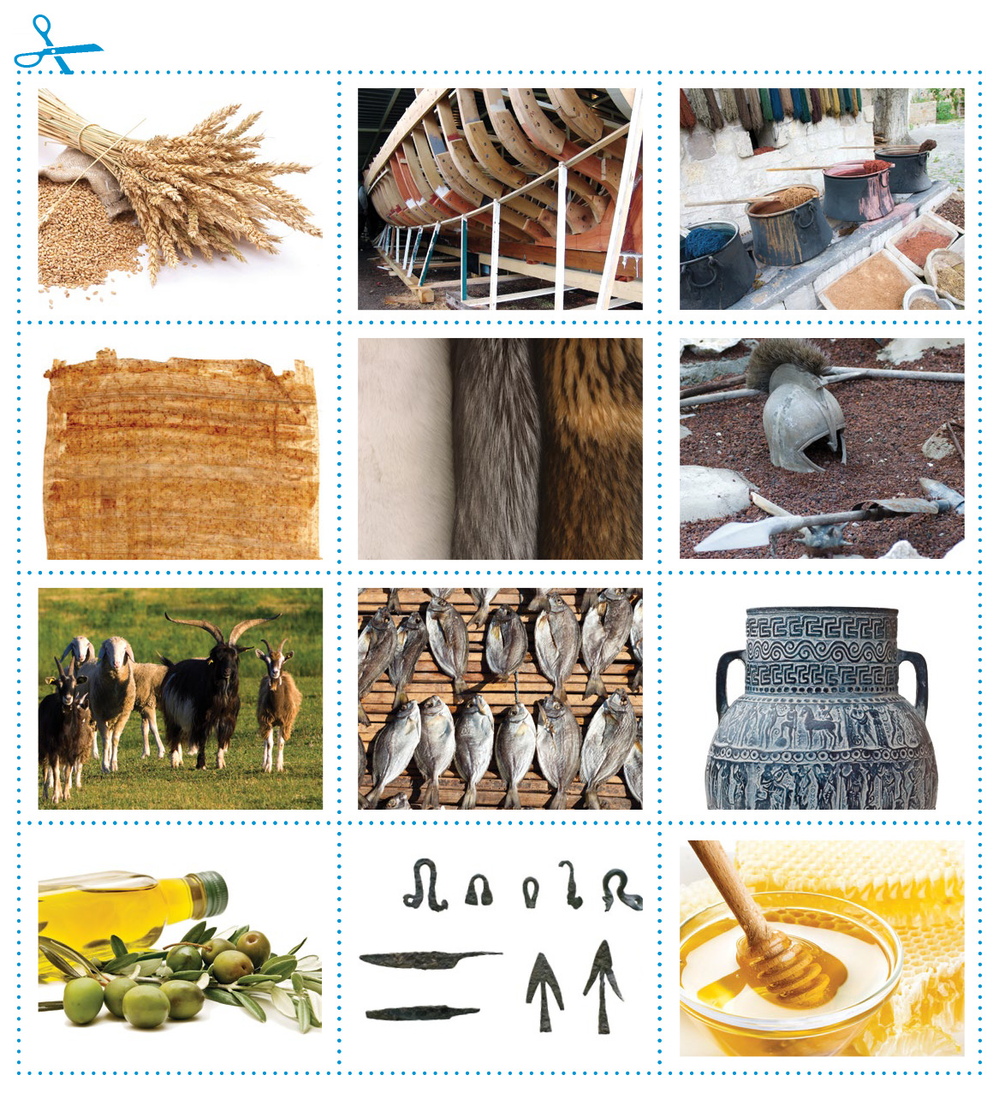
APPENDIX A
Ancient Greek Trading Card Matching Words
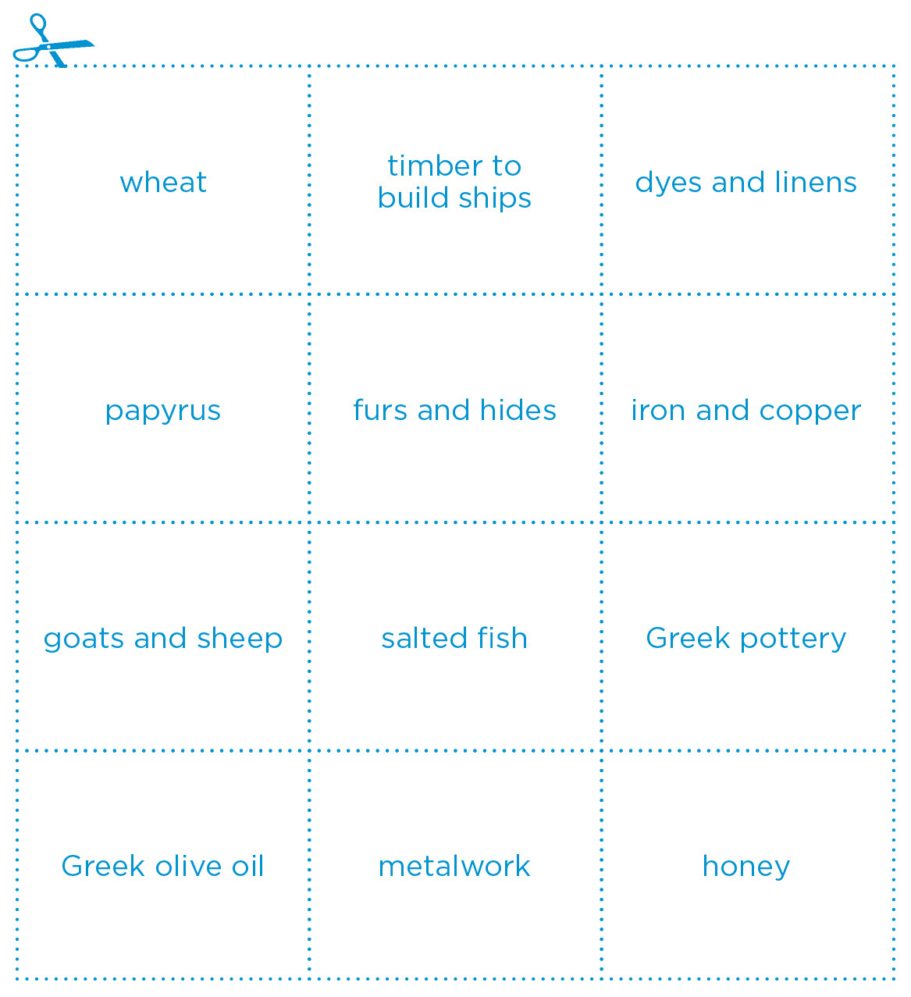
APPENDIX B
Reflection on Trading Market (Part I)
APPENDIX C
Name: ______________________________ Date: ____________________________________

- Were the trades fair? Why or why not?
________________________________________________________________________________
________________________________________________________________________________
________________________________________________________________________________

- Name two things that you did during this activity to help your group achieve its trading goals.

________________________________________________________________________________
________________________________________________________________________________
________________________________________________________________________________

- What strategy did your group use to try and meet the trading criteria?

________________________________________________________________________________
________________________________________________________________________________
________________________________________________________________________________

4. If you could do this activity again, what would you do differently?
________________________________________________________________________________
________________________________________________________________________________
________________________________________________________________________________

Reflection on Trading Market (Part II)
APPENDIX D
Name: ________________________________ Date: __________________________
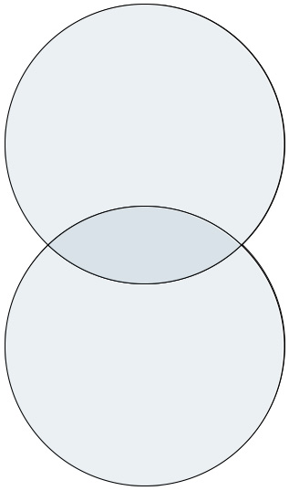
Fill in the following Venn diagram by explaining the difference between trade in Ancient Greece and in modern-day Canada. Record any points of similarity in the middle section.
Modern-day Canadian Markets

Ancient Greek Market

Rubric
Name: ________________________________________

Category | Level 1 | Level 2 | Level 3 | Level 4
Knowledge  Understanding of historical context of trade in Ancient Greece demonstrated in reflection. | Demonstrates limited knowledge of content. | Demonstrates some understanding of content. | Demonstrates considerable knowledge of content. | Demonstrates a high degree of knowledge of content.
Thinking  Use of planning  skills during  trading simulation demonstrated  in reflection  (Part I). | Uses planning skills with limited effectiveness. | Uses planning skills with some effectiveness. | Uses planning skills with considerable effectiveness. | Uses planning skills with a  high degree of effectiveness.
Communication  Expression and organization of ideas and information  in reflection  (Part I). | Expresses and organizes ideas with limited effectiveness. | Expresses and organizes ideas with some effectiveness. | Expresses and organizes ideas with considerable effectiveness. | Expresses and organizes ideas with a high degree of effectiveness.
Application  Connections between trade in Ancient Greece and modern-day Canada reflection  (Part II). | Makes connections between ideas, process and design with limited effectiveness. | Shows connections between ideas, process and design with some effectiveness. | Makes many connections between ideas, process and design with considerable effectiveness. | Makes connections between ideas, process and design with a high degree of effectiveness.

Comments:
________________________________________________________________________________
________________________________________________________________________________

Mark: __________________ Parent initials: __________________
APPENDIX D
Ancient Greek Notes
Name: ________________________________________

In the spaces below, jot down any notes or sketch ideas that will help you better understand how trading worked in Ancient Greece.

General Facts about Trading Markets | The Importance of Trade
The Geography of Ancient Greece | The Seas of Ancient Greek

APPENDIX E

